**Monero Meetup Kit Activities**

Your Monero Meetup Kit came with ten paper wallets with ~0.02 XMR each. Below are several educational activities that can teach the basics of using Monero firsthand. You will use two paper wallets for these activities.

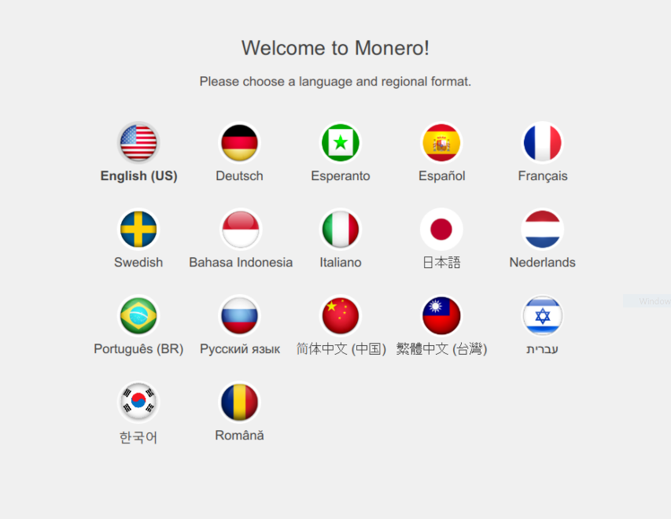

**Monero Desktop GUI Account**

Download the official Monero GUI from getmonero.org/downloads. We suggest the full version (not the command-line only version).

Extract the files into a folder. There are three important files: monerod, monero-wallet-cli, and monero-wallet-gui. Open monero-wallet-gui by double-clicking on it.

It should begin by prompting you for a language. Choose your preferred language and proceed.

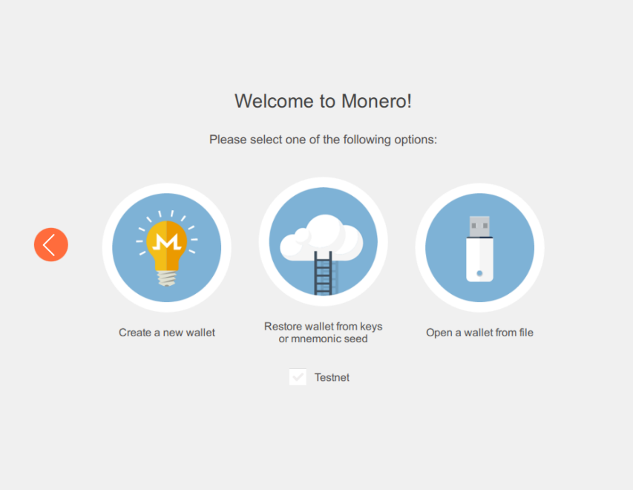

It should now prompt you for a method of restoring or creating an account. Select the middle option “restore wallet from keys or mnemonic seed”.

Start by giving the wallet a name of your choice. You need to type in the mnemonic seed. This is the set of 25 words on a paper wallet. Set the restore height to 1440000 to save wallet sync time, and manually choose your preferred storage location.

Proceed using a password. It does not have to be strong, since you will not use this account ever again. You need to create your own account to prevent people like this author from stealing your coins.

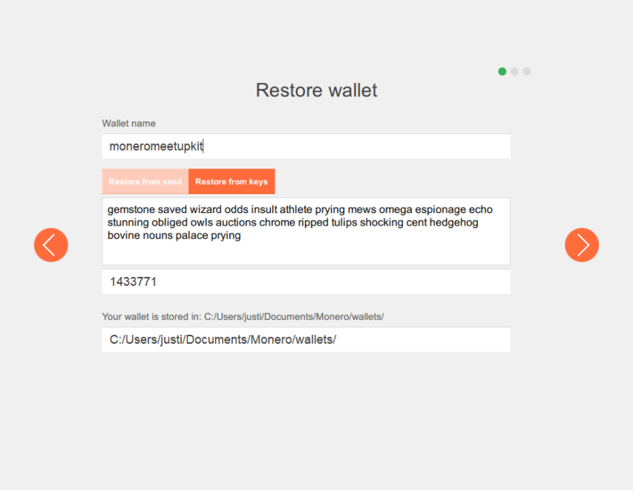Click “use Monero”. Now, it is important for you to click “use custom daemon settings” when it gives you a countdown before the daemon is automatically started. It is best to run your own daemon, but this takes a lot of time. For convenience, we will use a remote node. After you click on the custom daemon settings option, you will see the settings page.

Change the fields that say “localhost” and “18081” to “node.moneroworld.com” and “18089”, respectively. 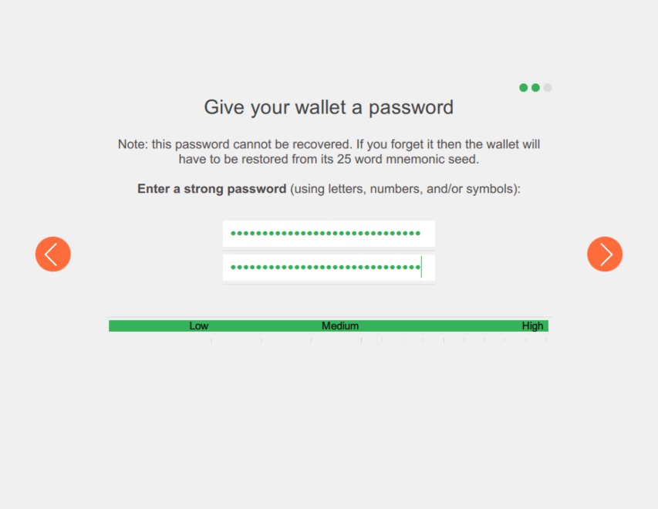Leave the username and password fields blank and click “connect.” Your wallet should scan blocks for a few seconds, and then the wallet balance should appear.

Congrats! You now have a Monero account on desktop!

